EE-281 Logic Design Lab

Lab #4

Alarm System

## Name: Ajin Sunny and Derek King

## Date of Experiment: March 9th, 2015

## Date of Completion of Report: March 23rd, 2015

# **Introduction**

In this Lab we will be implementing a rock paper scissor game where the individual or the player will be playing against the FPGA board , where the FPGA board will be the computer. This Lab is divided into two parts and this is the first part of the Lab where we will be only implementing the test module which makes the choice between the player and the human.

# **Experiment Description**

The experiment will make the choice between player **input [1:0] p** the computer (FPGA board) **input [1:0] c**. This will produce an output of the winner in 2 bits **output[1:0] win** . The choices of the game play is defined as below:

ROCK – 00

PAPER – 01

SCISSOR – 10

Unused – 11 (should not occur)

We first started coding the module required for the game where Rock, paper and scissor are the inputs for the program and the logic behind the game is **rock beats scissor , scissor beats paper and paper beats rock.** We will also have a default case where **default: win = 0;**

**Below is the module which decides the winner between the player and FPGA and the logic mentioned above is implemented in this code below.**

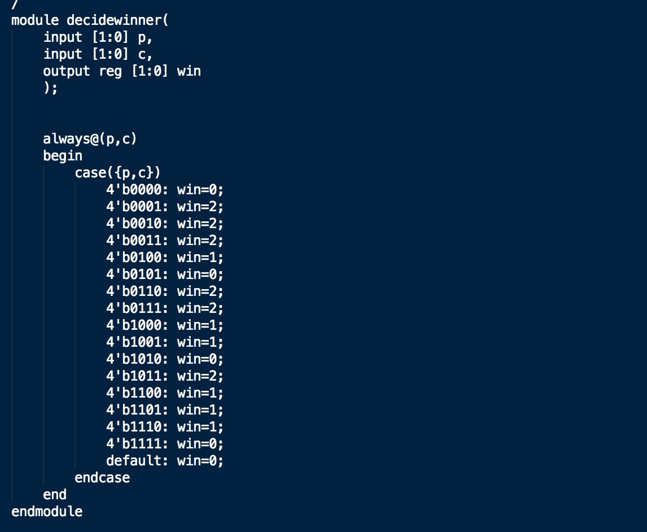

Now the module shown below is the module used to display the seven segment display of who the winner is:

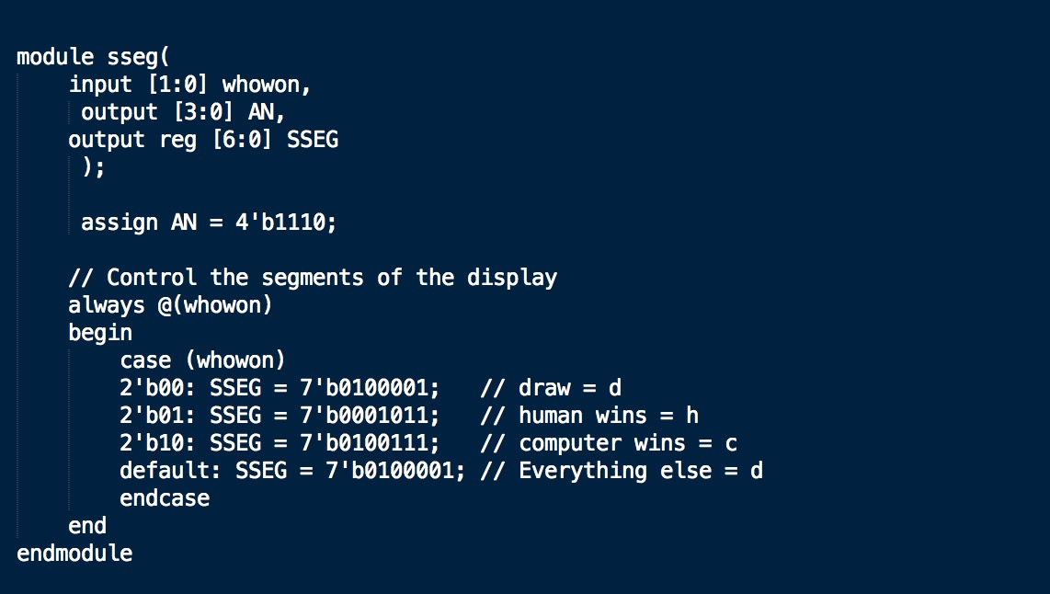

# **Results**

After implementing the above Verilog code, our Spartan3 FPGA board was able to display the correct winner. For the computer and human input we used switches. For further development of this game it would be important to have the computer choice be ‘random’. For now though, this program implements the correct logic for determining the winner of the game based on the input switches.

# **Conclusion**

In conclusion, this lab builds upon our Verilog knowledge. We will be using Verilog for the remainder of the class, so it is important that we understand how it works with the FPGA boards that we will continue to use. For future labs, I hope we can revisit this and make the game more engaging by adding ‘random’ computer choices as well as a scoring system.